Aditi Teriar
GEOG 381 Exercise 1

Question A
23.10371 %

Question B
Prairie County, Montana: 60.7

Question C
Valley County, Idaho: 29.2

Question D
I decided to change the color scheme and font, sightly change the bolded title, and decrease the sizing of the map and legend titles.
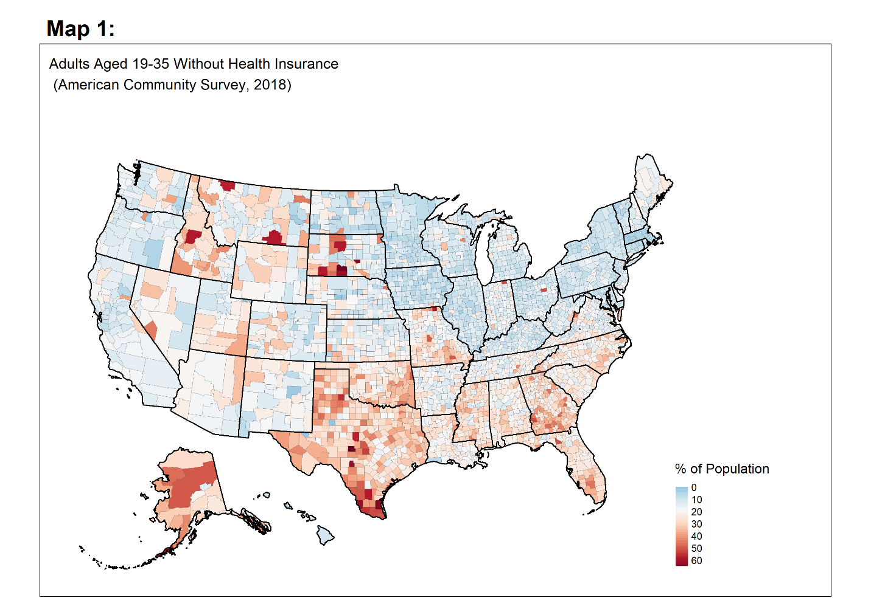
Question E
