Aditi Teriar
GEOG 360 Lab 4

Part 1
- Environmental racism is the collection of policies and regulations that corporations and government figures implement while knowing the impact that they will have on specific racial groups. This article discusses environmental racism in the context of the poisoning in Flint, Michigan. In this case, it Is well known knowledge that the poisoning was a direct result of an action that occurred due to the municipal Emergency Fiscal Manager. The author of this article notes how this case really emphasizes the “structural nature of environmental racism,” which is generally difficult to see. The wellbeing of the people of Flint was disregarded completely in the favor of financial interest. This is alarming because not only do colored people compose most of the Flint population, this follows historical patterns where people of color have been treated poorly for the sake of global capitalism. This is evident even in Flint’s history alone, as it was mistreated by the local state as the population incorporated more black and colored individuals, through the reduction of services and infrastructure. It is important to note that these actions occurred deliberately, with government officials knowing the possible consequences.
Source: https://www.tandfonline.com/doi/full/10.1080/10455752.2016.1213013

- This document examines how black women have an increased mortality risk compared to white women, and a drastically higher incidence rate for breast cancer. We currently don’t have a solid understanding of the social factors that play a part in this disparity. To gain a more in depth understanding of social detriments, we need to investigate psychosocial and physical risk factors and how socioeconomic status and racism influence them. Further into the document, there is an overview of the link between cumulative adversity and disease, socioeconomic status and breast cancer, stress and breast cancer, and prenatal and early like exposures. It also describes environmental exposures, prevention and healthcare intervention. The conclusion outlines how black women are at a severe disadvantage in several areas regarding social, economic and health resources. The combination of these factors, in addition to social and psychological developments In the social context, help us dive deeper into the relationship between black women and breast cancer incidence.
Source: https://www.ncbi.nlm.nih.gov/pmc/articles/PMC5588632/

- Based on my research, I believe that the final map will show a trend where black women have an increased rate of breast cancer incidence and mortality in comparison to white women and their respective incidence and mortality rate for breast cancer. I think areas with more people of color in their population will have more cases of breast cancer incidence and mortality.
- This data was collected by The American Cancer Society in 2017. Because they collected mortality rates as well as incidence rates, I would assume that they consulted hospitals for this data and that it is accurate for the most part.

Part 2
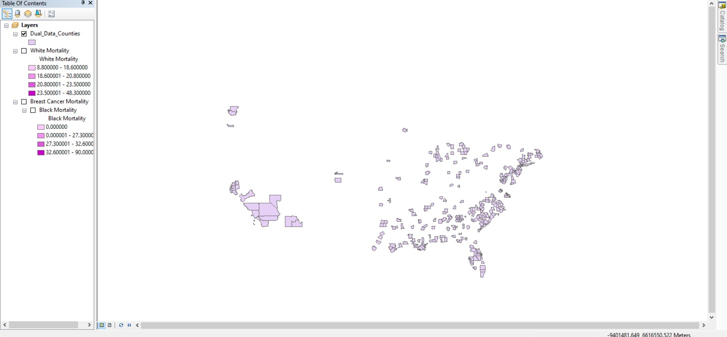

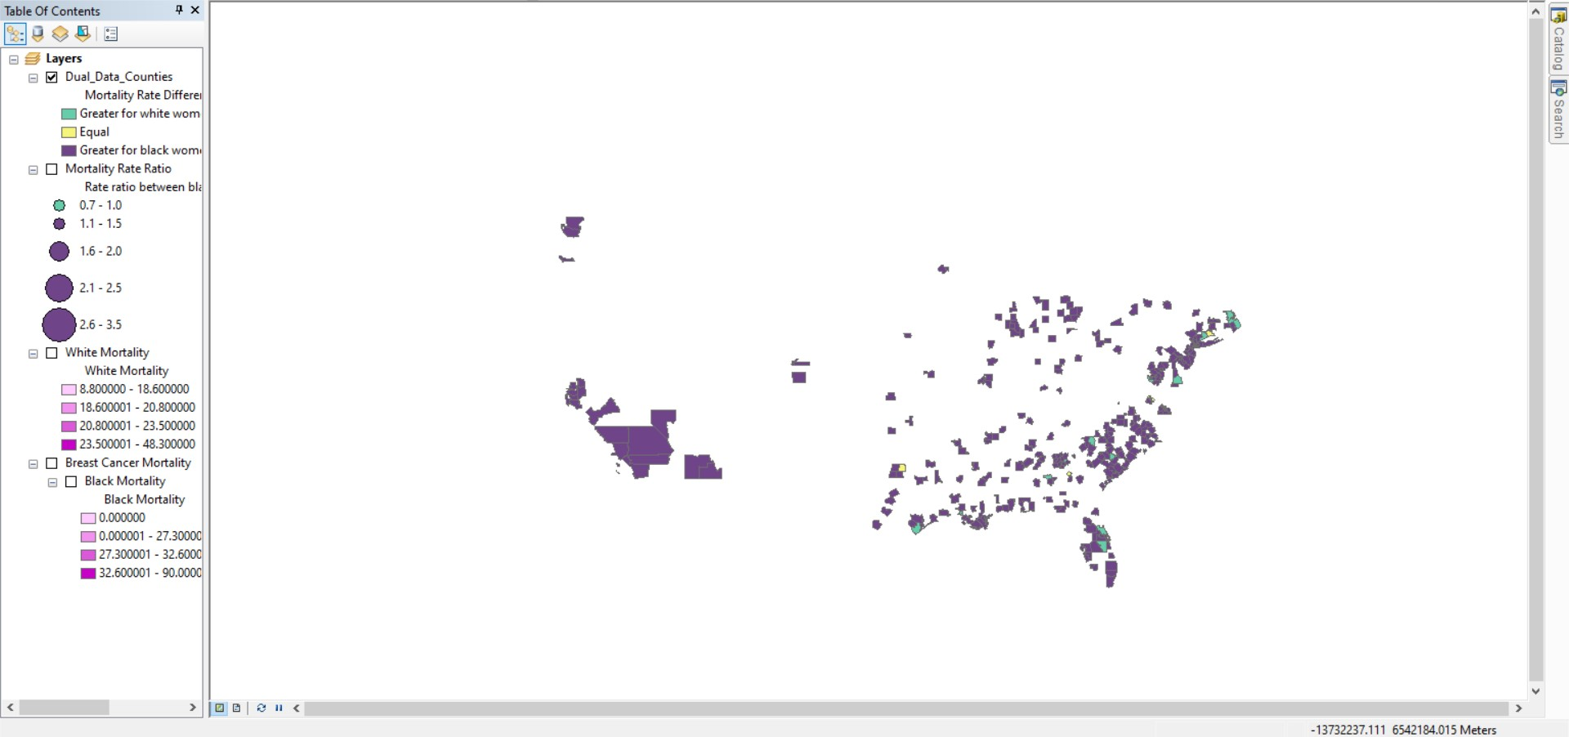

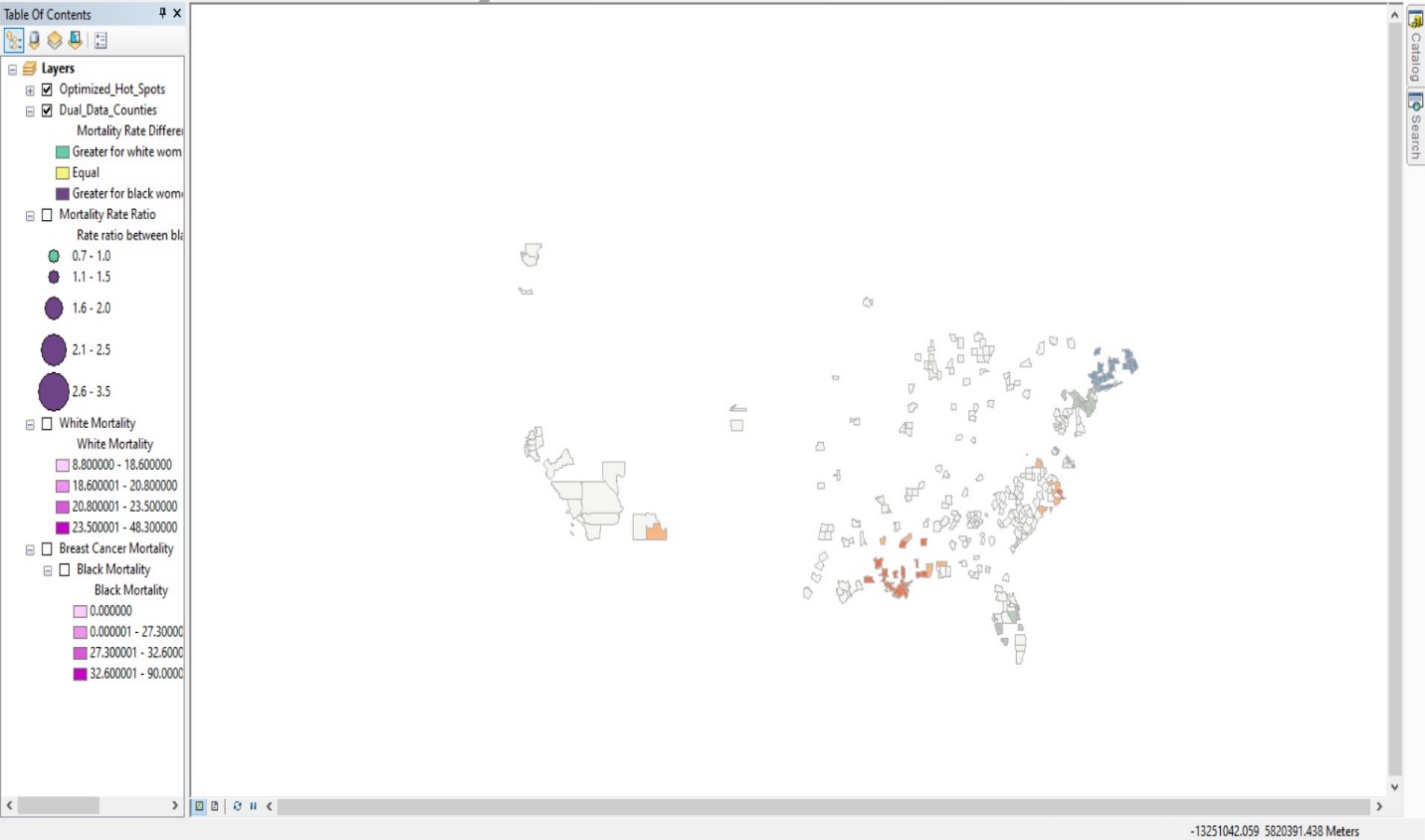

Part 3
In this analysis, we explored the mortality rate maps, mapped the mortality rate difference, and mapped the mortality rate ratio. The first component confirmed the NYT article, that there is a mortality gap between black women and white women. Next I calculated the mortality rate gap, using a rate ratio that compares mortality rate in two groups with different races. More specifically, I divided the rate for black women by the rate for white women. With this calculation I conducted a hot spot analysis to display which areas have the highest mortality rates. This is valuable data for the medical field and can be used to target more susceptible groups with resources tailored to them.
The results in the map shows that there is clustering in the rate ratio values. This supports the idea that certain areas seem to have the same susceptibility to breast cancer incidence and mortality. It is likely that people who live near each other are of the same race and socioeconomic status. There is a spatial difference in mortality rate patterns regarding black women and white women. These results are in line with the research and claims that I read about in my literature review. There may be a relationship between being a woman of color and being more susceptible to breast cancer incidence and mortality due to the several social and economic implications of being a woman of color. While we can’t make any causal conclusions based only on this dataset, it is enough to support the idea that there may be a relationship here that is worth being explored in future investigations. I think exploring this potential trend in different ways would be useful, and we can also take it a step further by examining socioeconomic status in black women and white women, and eventually ages as well.

